Name : Ahmed Adel Salah Abdel Aal Salem Hany

B.N : 16

Date : 8/6/2021

Topic : Database Systems

Application Brief : I chose the topic of database systems because of its importance in our time and I will talk about Properties, Advantage, Components, Applications.

**Database Systems Main Page**

**links:**

* Main page
* Properties
* Advantages
* Components
* Applications Of Database

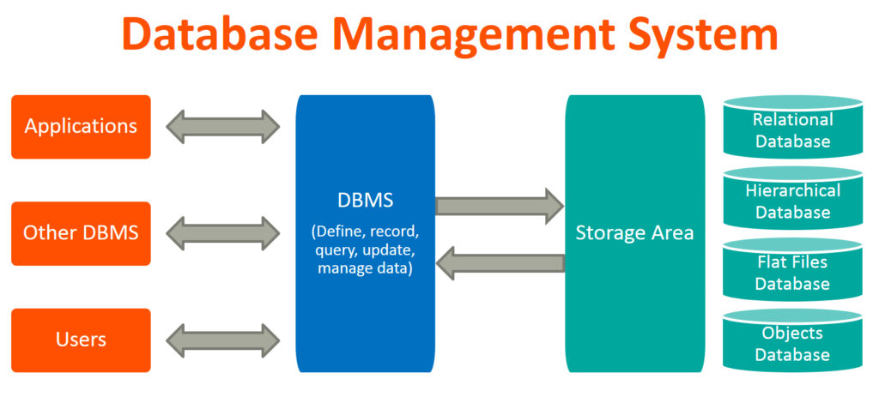 Every information system has a database at its core. That makes an understanding of database systems an essential skill for a computer scientist or information technologist. During the past 50 years – since its inception – the area of database systems has matured into a well-established, conventional subject. However, new ideas are continuously developed and new challenges and issues constantly appear. These need to be addressed from both a theoretical and practical standpoint. This subject can be seen as consisting of a ‘classic’ and a ‘young’ component. The former is based almost entirely on the relational model and at the time of writing still represents, de facto, the standard approach of most industrial applications. The latter proposes new models and architectures for database systems, and forms a growing part of internet-based uses.

**Database Systems Properties Page**

**links:**

* Main page
* Properties
* Advantages
* Components
* Applications Of Database

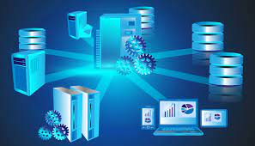 The properties of a database are • Atomicity. • Consistency. • Isolation. • Durability. Atomicity: Atomicity in database ensures that the transactions are indivisible and irreducible where transactions either commit or abort. If a part of transaction fails then entire transaction fails. Consistency: Any change in the values of a database at particular instance are consistent with changes to other values. Consistency on any transaction acts as a predicate for the data which serves as • Precondition. • Postcondition. • Transformation condition. Isolation: Transaction in database ensures that the working transaction will not be changed or affected by any other transaction. In other words, modifications or updates made on one transaction is not viewed or changed by any other transaction. Isolation also ensures the effect of database is same when • Transactions are executed serially or • Executed in an interleaved fashion. Durability: Durability of the databases states that “once transaction has been committed, should remain in the same status” even in the case of failures such as • Power loss. • Database crash, etc.

**Database Systems Advantages Page**

**links:**

* Main page
* Properties
* Advantages
* Components
* Applications Of Database

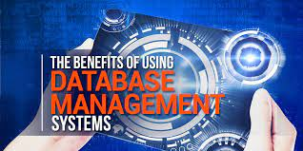 1. Improved data sharing An advantage of the database management approach is, the DBMS helps to create an environment in which end users have better access to more and better-managed data. Such access makes it possible for end users to respond quickly to changes in their environment. 2. Improved data security The more users access the data, the greater the risks of data security breaches. Corporations invest considerable amounts of time, effort, and money to ensure that corporate data are used properly. A DBMS provides a framework for better enforcement of data privacy and security policies. 3. Better data integration Wider access to well-managed data promotes an integrated view of the organization’s operations and a clearer view of the big picture. It becomes much easier to see how actions in one segment of the company affect other segments. 4. Minimized data inconsistency Data inconsistency exists when different versions of the same data appear in different places. For example, data inconsistency exists when a company’s sales department stores a sales representative’s name as “Bill Brown” and the company’s personnel department stores that same person’s name as “William G. Brown,” or when the company’s regional sales office shows the price of a product as $45.95 and its national sales office shows the same product’s price as $43.95. The probability of data inconsistency is greatly reduced in a properly designed database. 5. Improved data access The DBMS makes it possible to produce quick answers to ad hoc queries. From a database perspective, a query is a specific request issued to the DBMS for data manipulation—for example, to read or update the data. Simply put, a query is a question, and an ad hoc query is a spur-of-the-moment question. The DBMS sends back an answer (called the query result set) to the application. For example, end users, when dealing with large amounts of sales data, might want quick answers to questions (ad hoc queries) such as:- What was the dollar volume of sales by product during the past six months? What is the sales bonus figure for each of our salespeople during the past three months? How many of our customers have credit balances of 3,000 or more? 6. Improved decision making Better-managed data and improved data access make it possible to generate better-quality information, on which better decisions are based. The quality of the information generated depends on the quality of the underlying data. Data quality is a comprehensive approach to promoting the accuracy, validity, and timeliness of the data. While the DBMS does not guarantee data quality, it provides a framework to facilitate data quality initiatives. 7. Increased end-user productivity The availability of data, combined with the tools that transform data into usable information, empowers end users to make quick, informed decisions that can make the difference between success and failure in the global economy.

**Database Systems Components Page**

**links:**

* Main page
* Properties
* Advantages
* Components

* Applications Of Database

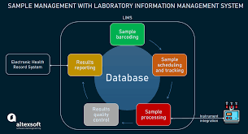 A database consists of: 1-Database structure Which is conceived as a single entity consisting of a collection of interrelated files. 2-Repository Which contains the rules under which users can access the data and the rules under which the data is organised ie metadata. 3-End users Who access the database. 4-Interfaces Which are the various ways an end user may access the data via display terminals, phone links from remote terminals, touch screens, bar code readers, by using voice commands, touch pads, graphics selection, selections from menus with keyboard or mouse, keying in commands or scanning cards. The interface also is the form in which the information is delivered to the end user eg graph, printed report, graphical display. 5-Application programs Which are used to perform the main operations on the data ie create, modify, delete and retrieve. Application programs also combine the data in meaningful ways to produce reports. 6-Database Management System (DBMS) Which is the collection of programs that manages the database structure and interprets the rules in the repository and also manages user access in multi-user systems. 7-Computer Aided Software Engineering Tools (CASE tools) Are also considered to be part of the database environment. These are automated tools to assist with the design of systems and databases. 8-Database Administrators (DBA) Manage the DBMS and are responsible for the overall information resources of an organisation. You will look at the role of the DBA more fully in a later section. 9-System Developers Include systems analysts and programmers. You will look at the role of each of these in other modules. Both use CASE tools to assist in the development of application programs.

**Applications Of Database Systems Page**

**links:**

* Main page
* Properties
* Advantages
* Components
* Applications Of Database

 Applications where we use Database Management Systems are: Telecom: There is a database to keeps track of the information regarding calls made, network usage, customer details etc. Without the database systems it is hard to maintain that huge amount of data that keeps updating every millisecond. Industry: Where it is a manufacturing unit, warehouse or distribution centre, each one needs a database to keep the records of ins and outs. For example distribution centre should keep a track of the product units that supplied into the centre as well as the products that got delivered out from the distribution centre on each day; this is where DBMS comes into picture. Banking System: For storing customer info, tracking day to day credit and debit transactions, generating bank statements etc. All this work has been done with the help of Database management systems. Sales: To store customer information, production information and invoice details. Airlines: To travel though airlines, we make early reservations, this reservation information along with flight schedule is stored in database. Education sector: Database systems are frequently used in schools and colleges to store and retrieve the data regarding student details, staff details, course details, exam details, payroll data, attendance details, fees details etc. There is a hell lot amount of inter-related data that needs to be stored and retrieved in an efficient manner. Online shopping: You must be aware of the online shopping websites such as Amazon, Flipkart etc. These sites store the product information, your addresses and preferences, credit details and provide you the relevant list of products based on your query. All this involves a Database management system.

Source Code :

<html>

  <body>

  <h1>Database Systems Main Page</h1>

 <h2> links: </h2>

  <ul>

    <li><a href="index.html">Main page</a></li>

    <li><a href="properties.html">Properties</a></li>

    <li><a href="advantages.html">Advantages</a></li>

    <li><a href="components.html">Components</a></li>

    <li><a href="applications of database.html">Applications Of Database</a></li>

</ul>

</body>

</html>